Activity Details
Activity Name: | (Insert Activity Name)
Date of completion: | (Insert Date)
RA review date: | 30/08/2021

Ongoing Assessment
This Risk Assessment is an ongoing assessment, which means it must be ‘dynamic’ and ‘on-going’. This means that as well as this virtual RA being made, the committee must mentally observe, assess and analyse the event environment while the event is running to identify and remove possible risks. This process allows individuals to identify a hazard on the spot and make quick decisions in regards to their own safety and the safety of others.
If you see a risk that cannot be covered, or control measures aren’t sufficient – then the activity must not proceed.
All individuals involved in the running of the activity/event must be fully aware of possible risks, and receive full guidance and instructions on how to manage these risks. Individuals involved must also be aware on their role within the activity, their responsibilities and how to control risks that may occur.
Any accidents that occur must be reported to your Student Opportunities Coordinator as soon as possible – you can find the accident form under important forms in the Committee Hub on the SU website. Any incidents or questions involving insurance must be referred to your Student Opportunities Coordinator as soon as possible.

ARU Students’ Union
Annual Ongoing Risk Assessment for Activities

What is an Annual Ongoing Risk Assessment?

An Annual Ongoing Risk Assessment is a risk assessment completed yearly that covers all regular society or sport activity during that year period. It is designed to cover the activities that your society or club undertakes (E.g. Meetings, Training, Socials, Competitions, and Trips in the UK). With this ongoing RA, you must make additions each time a new activity is being run, which has new risks associated with it. The updated RA then needs to be sent to your Student Opportunities Coordinator for approval before your activity takes place.

How to fill out the Annual Ongoing Risk Assessment

Much like Risk Assessments you may have completed before, you need to detail the hazard, the risks associated with the hazard, and how you plan to control these risks. Risk Assessments for Clubs and Societies at Anglia Ruskin Students’ Union also include a risk matrix to help complete the form. Incomplete Risk Assessments will be returned to the sender for improvement before approval.
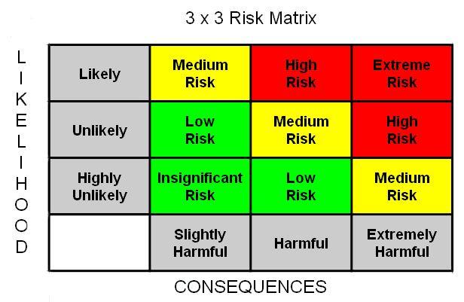
Risk Rating Guide
Below is a simple guide to help risk assessors determine the risk rating of each hazard identified.
A Risk Assessment should be ‘Suitable and Sufficient’. That is to say:
- It should identify the risks arising in connection with the activity.
- It must consider all those who might be affected i.e. staff, students, etc.
- It should be appropriate to the activity and should identify the period of time for which it is to remain valid.
The “Risk Rating” is the level of risk before appropriate controls have been put in place.
Risk Rating | Action | Risk Score
Insignificant Risk | No further action required unless incidents occur | 1
Low Risk | No additional controls may be needed overall, but specific hazards may be reduced. Monitoring is required to ensure controls are maintained. Review if an incident occurs or more effective controls become available. | 2
Medium Risk | Efforts should be made to reduce the risk over a defined period of time. | 4
High Risk | Work should not be started until the risk has been reduced. If work is in progress Urgent action should be taken to reduce or control risks. | 6
Extreme Risk | The activity should cease until risks have been reduced to an acceptable level. | 9

“Residual Risk” is the risk remaining after appropriate controls have been put in place.
Residual Risk = Likelihood x Consequences
Likelihood | Score |  | The consequence |  | Score
Highly Unlikely | 1 |  | Slightly Harmful | Bruising, minor cuts, grazes, Strains, Sprains, | 1
Unlikely | 2 |  | Harmful | Loss of consciousness, blood loss, burns, breaks or injury resulting in Visit to A&E. Other non-permanent chemical effects. Corrosive toxic, flammable substances, mild chemical irritation of eyes or skin. Harmful, irritant substances | 2
Likely | 3 |  | Extremely Harmful | Permanent /partial/total disablement or other reportable injury/disease. Single Death or Multiple Death | 3

The Residual Risk should equal 4 or below (Medium Risk, Low Risk or Insignificant Risk). If the Residual Risk equals 5 or above (High Risk or Extreme Risk), then please talk to your Student Opportunities Coordinator before continuing with your activity/event assessment.
Hazard |  | What are the risks & potential injuries? | Who is at risk? |  |  | Risk Rating | What are the controls and actions? | Residual Risk rating | Who is responsible for the control?
Area of Activity : Indoor meetings
Area of Activity : Outdoor activities
Area of Activity : Online socials
Area of Activity: Fundraisers
Area of Activity: Trips
Area of Activity: Food events

Communication
Who needs to understand this assessment? | How will this be communicated to them? | Person Responsible | Date
Sign Off
Please detail how this risk assessment will be communicated to all parties who must comply (Completed by student):

The undersigned believe this assessment to cover all significant risks associated with the above activity and accept their responsibilities for ensuring associated controls are in place

Authorisation
Position | Print Name | Sign | Date
President
Student Opportunities Coordinator

