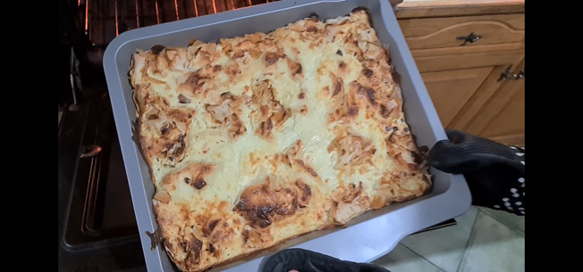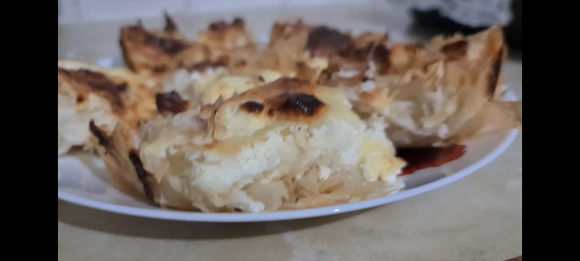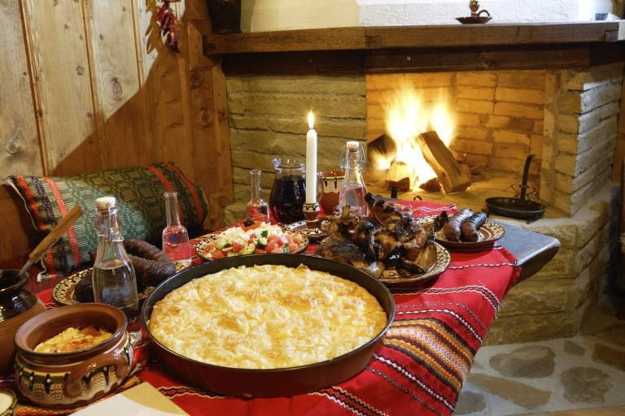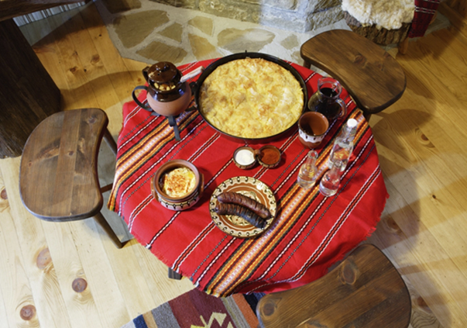

Saving a lot of times but if you want to create it more authentic see below.

**Lazy way……**

**Phyllo pastry 1 pack**

**Oil just a little before a phyllo in the tray and before the mix.**

**Mix**

**You pour it up on top of the phyllo than you bake for 25 minutes on 200 degree.**

**Eggs 3 or 4**

**White Chees 250 g**

**Yogurt 1 cup**

**Baking Soda half a teaspoon**

INGREDIENTS

BANITSA

BULGARIAN TRADITIONAL FOOD

Created by

Lyubka Damyanova

2020

Pictures

(italianrentalblog.wordpress.com)

It should be this way, but I show the fast one. The way of creating it is almost the same.

If you chose the second variant, use oil before the mixture inside the wrap of phyllo pastry and then after.

( [www.elizabethskitchendiary.co.uk](http://www.elizabethskitchendiary.co.uk))

