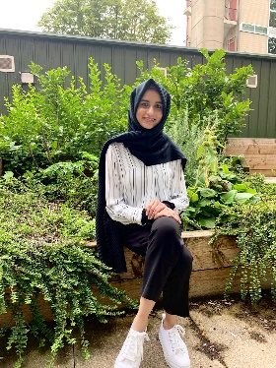

My name is Fatima and I am the VP AHSS for this academic year. I studied BA English Literature (HONS) and graduated this semester. Previously, I have actively involved myself with various university and SU activities like student ambassador, welcome buddy and society committee roles.
I was born and brought up in Saudi Arabia and then moved to Dubai for a couple of years. I studied commerce subjects as my GCSE subjects, so I do understand finance, business and economics at a fairly intermediate level. I love learning languages and currently learning Korean. My favourite colour is purple. ☺

