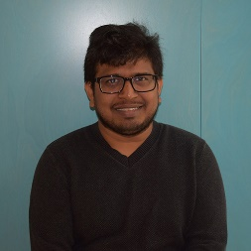

I am studying Master’s in film and Television Production and course rep to my class. I formed and run Indian Society as a president.

Mostly I use Facebook and WhatsApp to communicate people. If you any issues you can contact me on my mail at a.miriyam@angliastudent.com. You can fix an appointment in student union reception to meet me in person or you can walk-in as per my timetable.

What's your ultimate ARU moment?
My student life in ARU is the ultimate ARU moment, from Student to student ambassador, student buddy, founded and president of Indian society, course rep of my class, BAME committee member, member of active curriculum framework for Cambridge school of creative industries, part of library stars programme and finally to elect as student union president for 2020.

