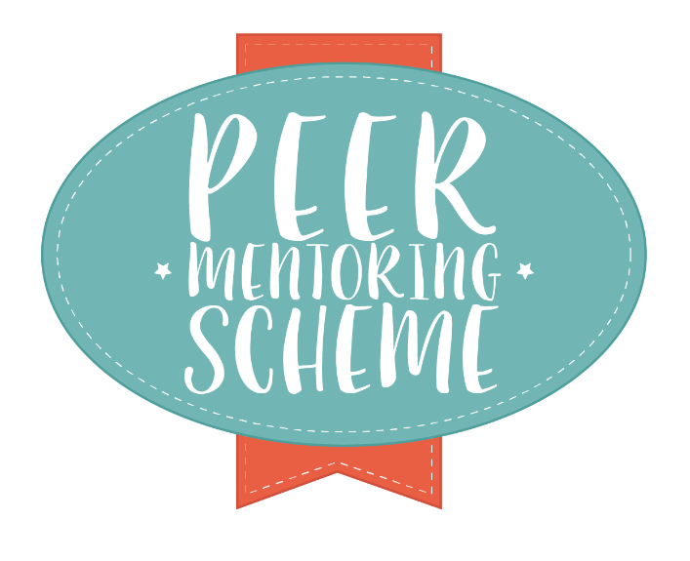

Tips for Active Reading
Two of the questions I thought a lot during my degree was “how do I actually remember everything I need to read?” and “how can I get what I want out of this text?” If you’re reading list is as long as mine, I think you know what I mean.

Reading actively is an important skill that can be extended to all different types of reading: books, journals, newspaper/magazine articles – you name it.

- Make sure you clearly understand the assignment question or research topic. Making brief notes about what you know and what you need to find out is a good place to start.
- Do you know how to get to the information you need? Now that you know a bit more about what you’re looking for, the library could be really helpful to you. You can access its study spaces and books, of course, but you can also get online content and look on the reading lists pages to find out how you can interact more with your course material. Your subject librarian will also know a lot about how you can get the most out of researching and the library!

Active reading can be thought of as a five step process: survey, question, read, recall, and review.

Survey: the skill of skimming over the text: i.e. trying to get a basic gist of the text, and not reading every single word. Rather, you are trying to decide whether certain sections are worth fuller reading. This skill takes practice.
Question: Writing down those questions that you want answered by your reading, e.g. have other people written about the Napoleonic Wars?
Read: Concentrate on a relevant text and read thoroughly.
Recall: Look back over what you’ve just read to make sure you understand.
Review: Write down the information that is relevant from your reading, the details of the resource (author, publisher, etc.) and the page(s) that your information comes from.

Reading introductions, abstracts and prefaces can save you a lot of time. You can gather from them whether if the text is worth further reading. When you combine active reading with critical analysis of a text, it will help you to start engaging with it.

Compiled with assistance from Cardiff University and Liverpool Hope University.

